**Verification Plan for SRAS(JAVADB1) Application**

**MySQL Minor Version Upgrade from 8.0.27 to 8.0.28**

**MASG-3SRASJAVADB1**

* Check - application is up & running.

As soon as we received the mail from the respective team, asking us to validate the application after the patching activity is over, hit these urls on the browser

As we have 2 apps on this server – CLRS and SMS Dashboard

**CLRS -** [**http://clrs.mas.net/**](http://clrs.mas.net/)

**SMS Dashboard - http://smsdashboard.mas.net/SMSDashboard**

Login page will be visible for this app.

Now you can login and move forward with the verification of application.

Simultaneously capture the artifacts for proof.

* Artifacts: CLRS

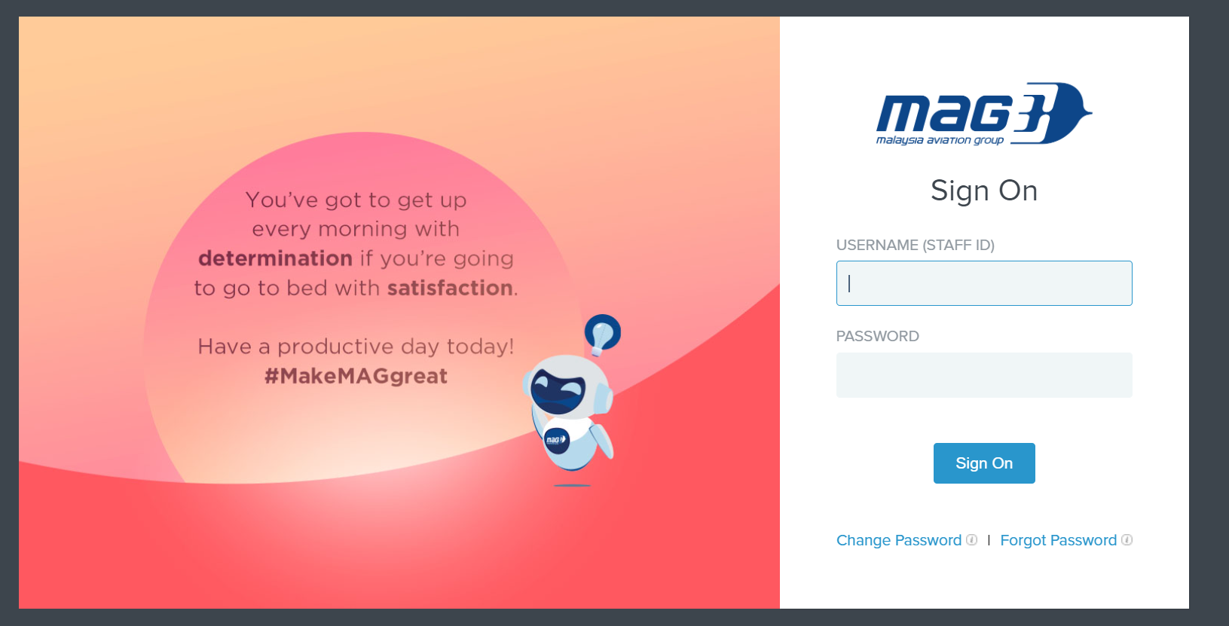

* Application Login is working fine.

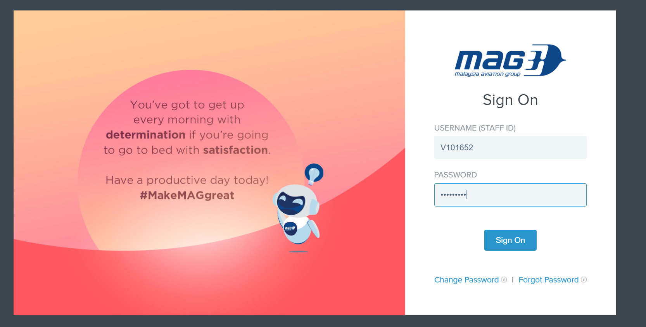

* Released functionality./Basic functionality.
* Home page - after login is successful

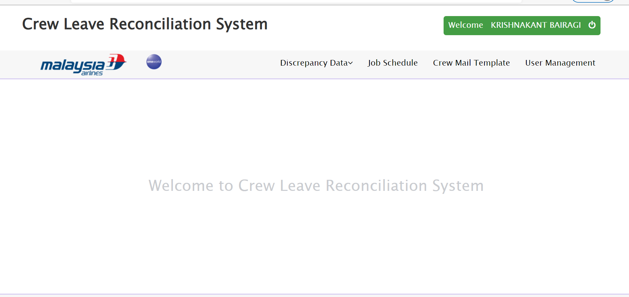

* Job Schedule

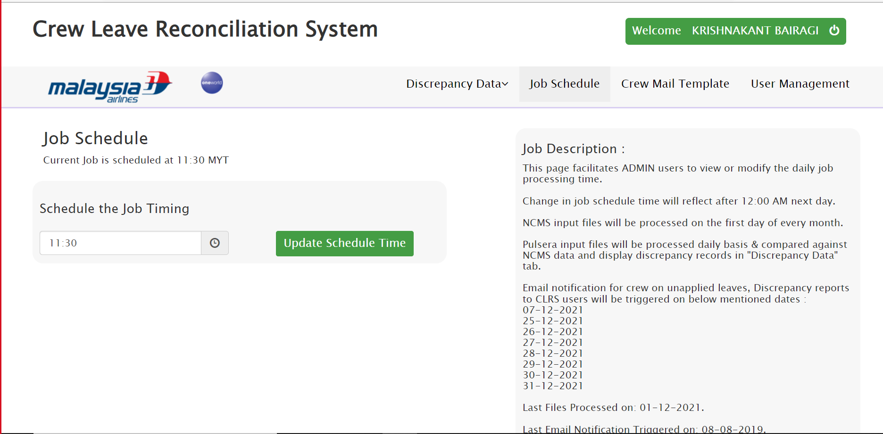

* User Management section

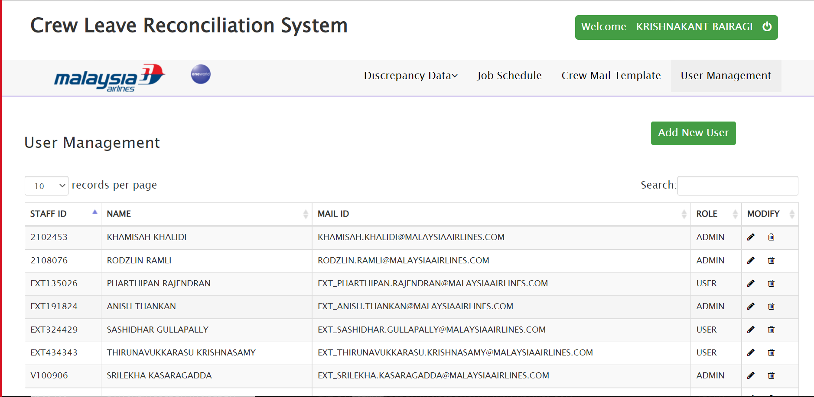

* Artifacts: SMS Dashboard



* Application Login is working fine.

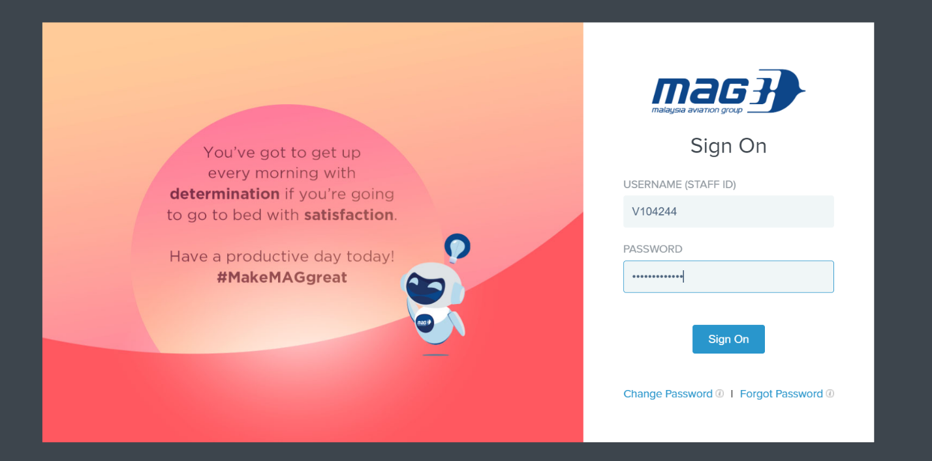

* Released functionality./Basic functionality.
* Home page - after login is successful

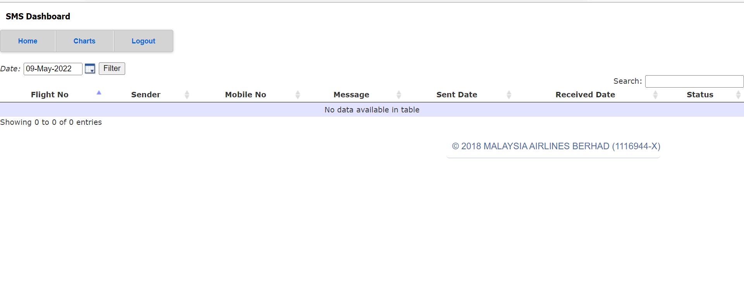

* Charts

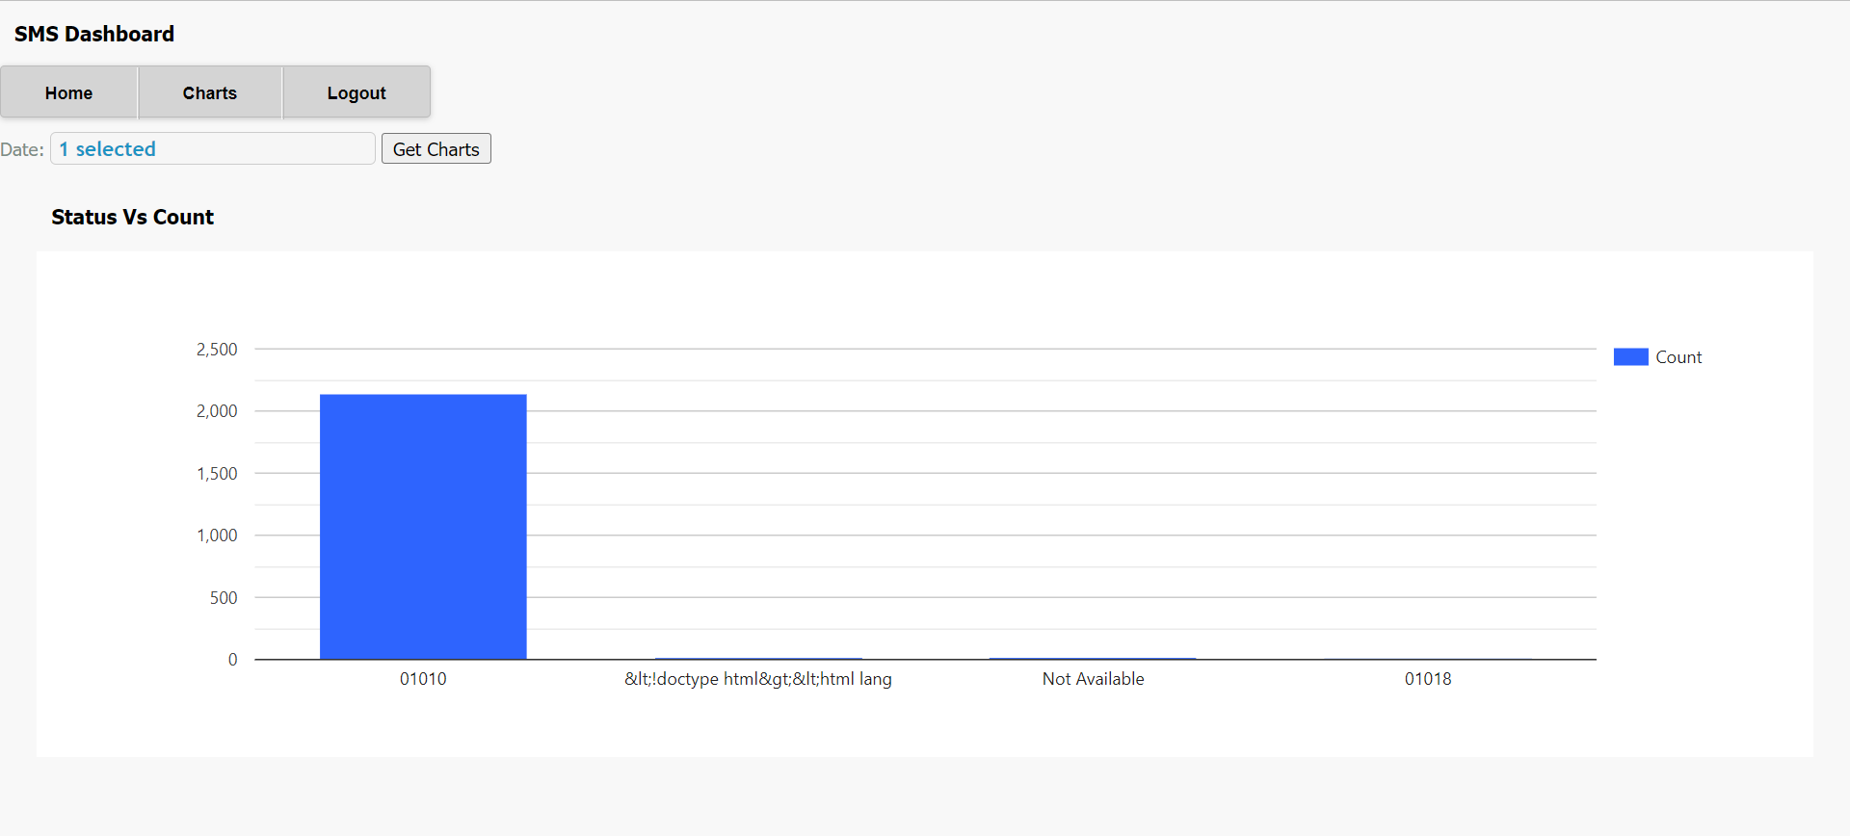

* Charts – for 3 selected dates

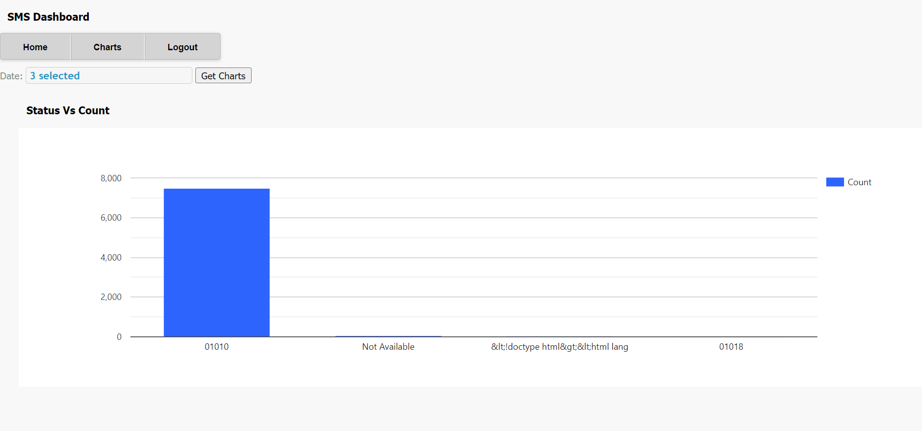

* Verify the log - Check for any unexpected error.

As you will be having the server access for this application – Check the logs with this

**ip- 10.221.4.29**

**logpath -** /tomcat/apache-tomcat/logs/sms.log

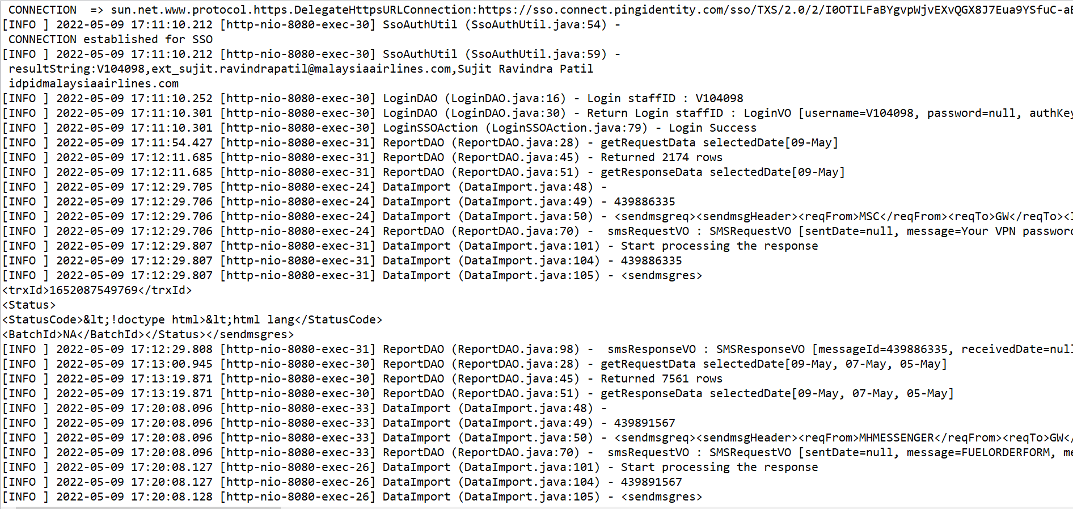

As we have validated the application and its working fine, now revert back with the same acknowledgement to that particular mail.

